Email Validator Document
1.Investigation:
Rules for a valid Email Address:
These are the rules that I have devised so far but more might need to added
depending on how the program is written
1. An email address must contain an @ symbol, which separates the local part
from the domain part of the address.
2. The @ symbol cannot be consecutive
3. There cannot be more than one @ symbol in an email
4. The @ symbol is allowed in between single quotes but if another one is
added in the email it won’t be valid
5. The local part of the email address (before the @ symbol) can contain
letters, numbers, and special characters such as !#$%&'*+-/=?^_{|}~, as
well as periods (.`), as long as they are not the first or last character and do
not appear consecutively.
6. The domain part of the email address (after the @ symbol) must be a valid
domain name, which means it must contain at least one period (.) and
consist of letters, numbers, and hyphens (-).
7. The top-level domain (the part after the last period) must be a valid top-level
domain such as .com, .org, or .edu.
8. The total length of an email address must not exceed 254 characters.
9. The @ symbol has to be more than 6 letters from the end of the email
10.@ symbol is a must
11.No spaces between
12.The local name may be a maximum of 64 letters long
13.Icon Characters aren’t allowed
14.Underscore is not allowed in domain part
15.Spaces, quotes and backslashes must be contained by quotes
16.Last portion of domain must be at least two characters e.g. .com
17.Punctuation marks can not come consecutively
18.Can’t have all punctuation marks
19.Must have the full stop separating the local and domain name
20.@ sign can’t be first
21.Hyphens can’t be first or last character
22.Normally capital and lowercase letter versions of email work and are
allowed
23.Space between “ ” is allowed
24.Any punctuation can go in quotes
25.IPV4 addresses to be checked
Eg: 123.123.123.123
[197.0.27.255] are valid IPV4 domain addresses
2.Python string methods used:
Task | Python Method | Example
Length of string | len() | len(email)
Character exits | in | ‘@’ in email
Character at index | email[i] | Email[0]
Index of Character | email.find(‘@)
Count Character | email. count(‘@’)
Split String | Split() | email.split(‘@’)

3.Flowchart:
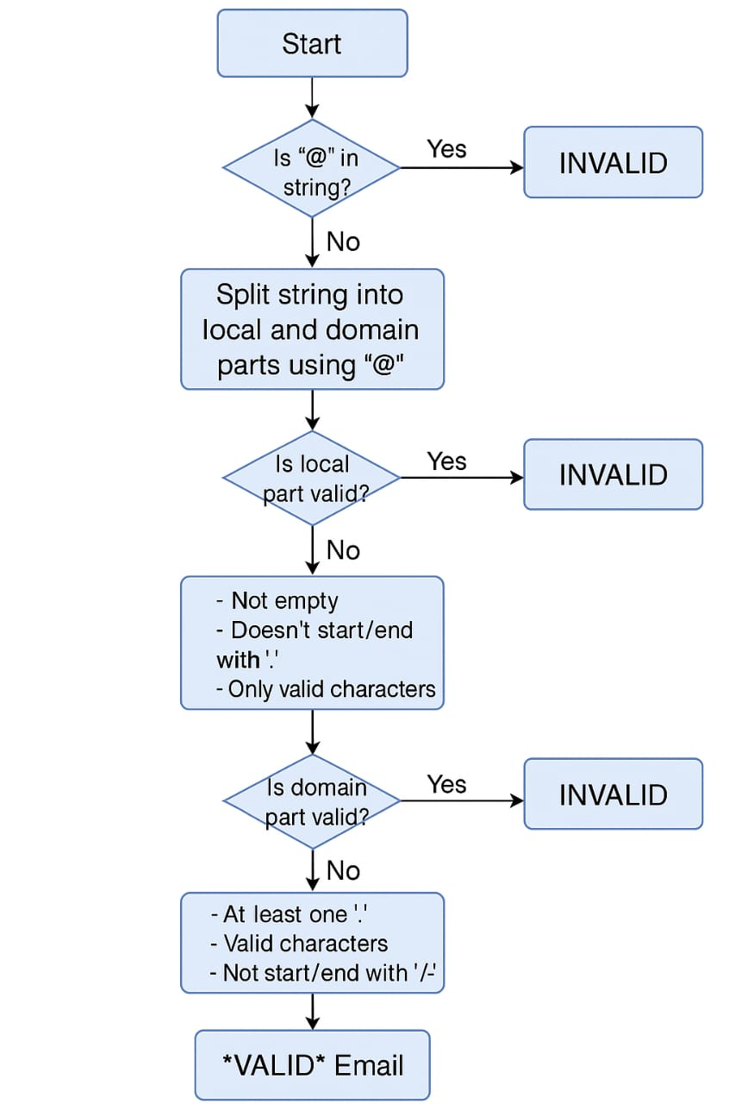

4.Pseudo code:
IF '@' not in email OR email.count('@') != 1:
return INVALID
Split email into local and domain
IF local is invalid:
return INVALID
IF domain is invalid:
return INVALID
return VALID

5.Build Phase:
a. Python function:
def ValidateEmail(email):
if '@' not in email or email.count('@') != 1:
return "INVALID"

local, domain = email.split('@')

if not local or local.startswith('.') or local.endswith('.'):
return "INVALID"

if not domain or '.' not in domain or domain.startswith('.') or domain.endswith('.'):
return "INVALID"

return "VALID"

Interactive Mode:
while True:
email = input("Enter email (or 'exit'): ")
if email.lower() == "exit":
break
print(ValidateEmail(email))

Batch Mode:
with open("input.txt", "r") as infile, open("output.txt", "w") as outfile:
for line in infile:
email = line.strip()
result = ValidateEmail(email)
outfile.write(f"{result} -- {email}\n")

Testing and evaluation of interactive:
I tested the interactive version using 12 sample emails. Valid ones like ethna@gmail.com passed, while invalid ones like .ethna@gmail.com were correctly flagged as invalid. The logic for validating character placement and domain format worked as expected.
Testing and evaluation of Batch version:
I used the Connect Library's test files and compared my program's output file. Most outputs matched the LABELS file exactly. My ValidateEmail() function handled invalid formats like myname@@domain.com and @user.com correctly.
Sample inputs and outputs:
Email Address Result
ethna@gmail.com VALID
.ethna@gmail.com INVALID
email@[123.123.123.123] VALID
@gmail.com INVALID
email@123.123.123.123 INVALID

